Assignment 06

Cryptology – b keerthana

AMRUTHESH

241059041

M.E – Cyber Security

MSIS, MANIPAL

**1. Python Script for Rail Fence Cipher (with 3 Rows)**

The Rail Fence Cipher is a form of transposition cipher where the plaintext is arranged in a zigzag pattern across multiple rails. The encryption involves reading the text off in rows.

Here’s a Python script for Rail Fence Cipher encryption with 3 rows and key "ONE":

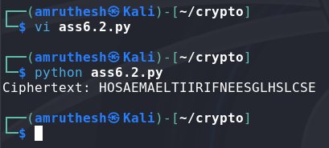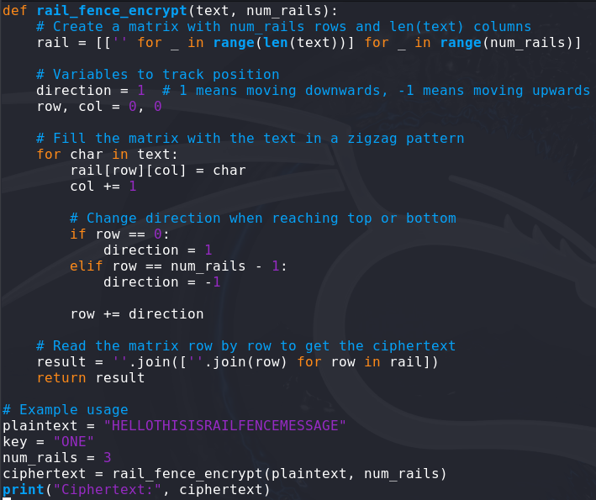

### 2. Python Script for Columnar Transposition Cipher

Columnar Transposition involves writing the message in rows and then reading the columns in a specific order, determined by a keyword.

Here’s a Python script for Columnar Transposition encryption:

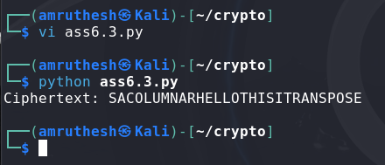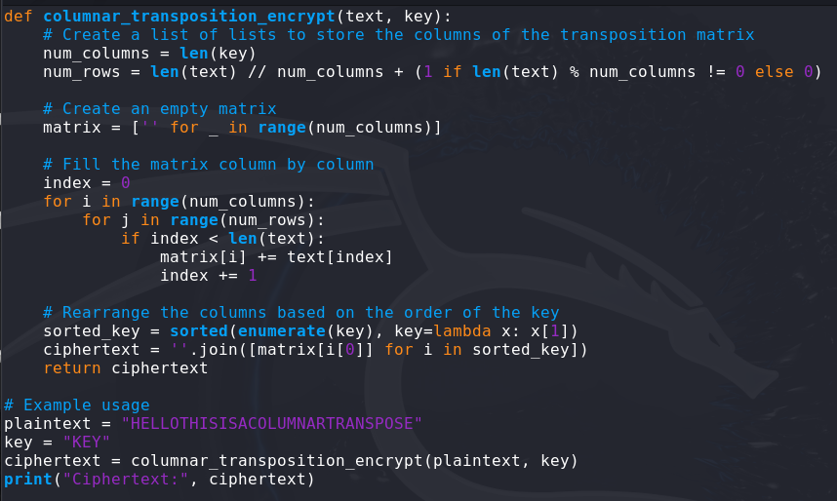

### 3. Python Script to Decrypt Rail Fence Cipher

The decryption of the Rail Fence Cipher essentially involves reconstructing the zigzag pattern and reading the plaintext from it.

Here’s the Python script for decryption:

